Profile
Department of Economics
Bhattadev University Bajali, Pathsala.

Name of the department: Economics, Arts Block-II, Bhattadev University Bajali, Pathsala.
Earlier Bajali College,Pathsala.
- Department at a Glance
- Year of Establishment:1962
From 1955 to 1962 it was known as Civics. In 1962 it was bifurcated into Economics and Political Science as Civics was bifurcated in Gauhati University in the year 1961.Late Harendra Nath Deka was the founder Head of the Department. Economics as a major subject had been introduced in 1963.Eight students studied Economics as a major subject in that year. Amongst them Ms. Renu Boro had retired as Head of the Department Economics, Barama College and Tarini Sarma had retired as Vice- Principal Nalbari College, Nalbari.
- Built Up Area:
No Specific area allotted except a Room of 360 Square Feet for teachers common room and seminar library.
- Asset : Table : 6 Nos.
Computer Table: 1
Chair: 8 (5 Wooden,3 Secretariat)
Steel Almirah: 4 Nos.
Water Filter: 1No.
Wall Magazine : 1
Notice Board: 1
Desk Top : 1
Printer/Xerox: 1
Fan: 2 nos.
- Seminar Library: The Department has a Seminar Library, which is assessed by the teachers and students of major classes of the department. Sometimes the students of P.G, Department of Geography, Bhattadev University Bajali, also assess this library.
- Source:Donated by teachers students and Central Library
Total No. of Books and Journals: 600
Rules of Seminar Library:
- The Departmental Library remains open on all working days during 9 a.m. to 5 p.m.
- The students of Major classes can use the library.
- Books are issued to the Major students on Overnight basis.
- A charge of Re.1/- for each book /day shall be levied on for the student if a book is kept
beyond the borrowing period.
- Writing, marking and underlining as well as tearing out the pages of the book is strictly
prohibited.
- Reference books are not issued to the students. These are to be studied in the department only.
- A decorum and discipline should be maintained in the library cum department.
- List of Retired/ Ex Faculties:
Sl.No | Name | Period( In Yr) |  | Remark if Any
 |  | From | To
1 | HARENDRA NATH DEKA | 1961 | 1994
2 | Satyanath Das | 1961 | 1966 | Left as he became the Founder Principal,  B H College, Howly
3 | Sampurnanda Talukdar | 1964 | 1999
4 | Prasanna Talukdar | 1965 | 2000
5 | Mohan Ch. Das | 1966 | 1996 | Left Job as he was elected as MLA of 42No.LAC , Assam, in 1996.
6 | Bharati Barua | 1972 | 1973 | Join in Leave Vacancy
7 | Jagat Hazarika | 1997 | 1998 | Left job and Joined as Officer in Indian Planning Commission.

- Number of teaching posts
 | Sanctioned | Filled
Professors | 00 | 00
Associate Professors | 02 | 02
Asst. Professors | 02 | 02
- Name of the Faculties of the Department:
Sl.No | Name | Qualification | Designation | Year of Joining | Remark
1 | Ritu Barua | MSc. | Associate Professor | 1998 | Head of the Department  Coordinator, Placement Assistance Cell
2 | Sirish Kumar Sarma | M.A | Associate Professor | 1994 | Coordinator, KKHSOU  Bajali Colllege Centre.
3 | Parag Barman | M.A.,  M. Phil. | Assistant Professor(Sr.) | 2000 | Research Scholar, Dept. of Economics  Bodoland University.  Coordinator  ICCGC, Bajali College
4 | Raju Das | M.A.,  M. Phil | Assistant Professor(Sr.) | 2000 | Superintendent, BHUC GH

3. Names of Programmes / Courses offered : UG Major and General
4. Names of Interdisciplinary courses and the departments/units involved:
B.Sc., B.A and B.Com
5. Annual/ semester/choice based credit system (programme wise):
Semester system is followed in all levels of UG curricula.
- Participation of the department in the courses offered by other departments:
TTM, Commerce, Political Science
7. Courses in collaboration with other universities, industries, foreign institutions, etc.: NIL
8. Details of courses/programmes discontinued (if any) with reasons: NIL
9. List of senior visiting faculty: Nil.
10. Percentage of lectures delivered and practical classes handled (programme wise) by temporary faculty:NIl
11. Student -Teacher Ratio (programme wise): UG(Maj) :30:1,UG(Gen):30:1
12. Number of academic support staff (technical) and administrative staff; sanctioned and filled: Nil
13. Qualifications of teaching faculty with DSc/ D.Litt/ Ph.D/ M. Phil / PG. : PG 4
M.Phil 2
14. Number of faculty with ongoing projects from a) National b) International funding agencies and grants received: 1(One) Minor Research Project, Rs.1,50,000.
17. Departmental projects funded by DST - FIST; UGC, DBT, ICSSR, etc. and total grants received: NIL
18. Research Centre /facility recognized by the University: NIL

19. Publications:
(a)Publication per faculty:

(a) Sirish Kr Sarma :
- Number of papers published in peer reviewed journals (national /International) by faculty and students : Nil
- Number of publications listed in International Database (For e.g.: Web of Science, Scopus, Humanities International Complete, Dare Database International Social Sciences Directory, EBSCO host, etc.): Nil
- Monographs : Nil
- Chapter in Books: Nil
- Books Edited : Nil
- Books with ISBN/ISSN numbers with details of publishers: Nil
- Citation Index: Nil
- SNIP: NIL
- SJR: NIL
- Impact factor: NIL
- h-index: NIL

(b) Ritu Barua :
- Number of papers published in peer reviewed journals (national /International) by faculty and students : Nil
- Number of publications listed in International Database (For e.g.: Web of Science, Scopus, Humanities International Complete, Dare Database International Social Sciences Directory, EBSCO host, etc.): Nil
- Monographs : Nil
- Chapter in Books: Nil
- Books Edited : Nil
- Books with ISBN/ISSN numbers with details of publishers: Nil
- Citation Index: Nil
- SNIP: NIL
- SJR: NIL
- Impact factor: NIL
- h-index: NIL

(c)Parag Barman :
- Number of papers published in peer reviewed journals (national /International) by faculty and students : Two
- Number of publications listed in International Database (For eg: Web of Science, Scopus, Humanities International Complete, Dare Database International Social Sciences Directory, EBSCO host, etc.) : Nil
- Monographs : Nil
- Chapter in Books: One
- Books Edited : As member of the Editorial Board: 6
- Books with ISBN/ISSN numbers with details of publishers: Nil
- Citation Index: Nil
- SNIP: Nil
- SJR: Nil
- Impact factor: Nil
- h-index: Nil

(d) Raju Das :
- Number of papers published in peer reviewed journals (national /International) by faculty and students : Nil
- Number of publications listed in International Database (For eg: Web of Science, Scopus, Humanities International Complete, Dare Database International Social Sciences Directory, EBSCO host, etc.) : Nil
- Monographs : Nil
- Chapter in Books: Nil
- Books Edited : Nil
- Books with ISBN/ISSN numbers with details of publishers: Nil
- Citation Index: Nil
- SNIP: Nil
- SJR: Nil
- Impact factor: Nil
- h-index: Nil

20. Areas of consultancy and income generated: Nil
21. Faculty as members in
(a) National committees: 3
(b) International Committees: Nil
(c) Editorial Boards….: One
22. Student projects
(a) Percentage of students who have done in-house projects including inter departmental/programme: NIL
(b) Percentage of students placed for projects in organizations outside the institution i.e.in Research laboratories/Industry/ other agencies: Data Not Available.
23. Awards/Recognitions received by faculty and students: Nil
24. List of eminent academicians and scientists / visitors to the department:
Sl.No. | Name | Designation
1 | Dr. Manjit Das | Professor, Department of Economics  Bodoland University
2 | Dr. Keshab Ch. Basumatay | Dean( Arts), Bodoland University, Kokrajhar
3 | Mr. Prasanta Goswami | Faculty, Indian Institute of Entrepreneurship, Guwahati.
4 | Dr. Archana Sarma | Retd. Prof. Dept. Of Economics, Gauhati University.
5 | Dr. Anjanjyoti Bhuyan | Assoiate Professor, MBA dept. Tezpur University.
6 | Sampurnanda Talukdar | Retd. HOD, Economics, Bajali College
7 | Prof. PranabKr. Sarma | Retd. Head, HRD,  Induiian Institute of Entrepreneurship,Guwahati.

25. Seminars/ Conferences/Workshops organized & the source of funding

(a) National: Two(2). Source of Funding is UGC.

i) A UGC sponsored National seminar is organized by the department of Economics, Bajali
College in Collaboration with Assam College Teachers’ Association on THE CONTEXT
OF LIFELONG LEARNING UN HIGHER EDUCATION at Bajali College on Sept.5-6,
2013. In connection with the observation of the International Literacy Day the Department of Economics of the college organised a two-day-long UGC-sponsored national seminar on the theme “The context of Life Long Learning in Higher Education” on September 5 and 6, 2013 in Collaboration with Assam College Teachers’ Association. The Inaugural Session of the seminar was presided over by Dr. Ratneswar Sarma, the president of Governing Body, Bajali College in which Dr. D N Sarma, the Principal of the College delivered the Welcome Address. Prof.Rana kumar Changmai, the President of Assam College Teachers’ Association, inaugurated the seminar by lightening the Ceremonial lamp and highlighted the different phases of lifelong learning beyond the domain, of university syllabi and curriculum in his speech. Prof. Ashok Barman, General Secretary, All India Federation of University and College Teachers’ Associations (AIFUCTO) delivered the keynote address and emphasized on the need of lifelong learning process and explained the basic difference between education and learning.. Dr.K.K.Patgiri, Ex-Principal, Bajali College, Abdul Mannab Sikdar, President of ACTA, Barpeta Zone, and Mr J.K.Patra, Retired prof. Bajali College were been felicitated in in the occasion.
Prof. Dilip Kumar Baruah, Former Dean, Cotton College, Dr Keshab Basumatry, Dean of Arts Bodoland University , Dr Kandarpa Das, Director, IDOL, Gauhati University, Dr Dulumani Goswami, Deptt. Of Education, Gauhati.University, Mr Samiran Brahma, Director State Resource Centre Assam, Dr Mukunanda Sarma, Principal, Bhawanipur Anchalik College, , Dr Manjit Das, Deptt. Of Economics, Bodoland University was participated as the Resource Persons of the seminar. The valedictory session was presided over by Dr DN Sarma, Principal of the College presided the valedictory session in which former Teachers of the department Mohan Ch.Das and Prasanna Talukdar graced the occasion as the invited guests. 52 researcher were presented paper in the seminar and 120 participants. In “Teacher Movement” the mouth piece of AIFUCTO, Prof. Ashok Barman, highlighted about the seminar.
ii) A UGC sponsored National seminar was organized by the Department of Economics, Bajali College on THE NEED OF ENTREPRENEURSHIP EDUCATION IN COLLEGES onNov.18-19, 2005 at Bajali College, Pathsala.
Inaugural Session:
Chair Person : C M Sarma, President, College GB.
Welcome Address: Dr. K K Patgiri, Principal, Bajali College.
Inaugurator : Dr. D Mazumdar, SDO (C ), Bajali.
KeyNote Address: Dr. G N Talukdar, Vice- Chancellor. Gauhati University
Distinguish Gueast: Dr. Hiri Kumar Sahoo. DHE, Govt. Of Assam.
Kahilipara.

. Student profile programme/course wise:
Name of the Course/programme (refer question no. 4) |  |  | Applications received |  |  | Selected |  |  |  | Enrolled |  |  |  |  |  | Pass percentage (%) |  | Year  Of  Examination
 |  |  |  |  |  |  |  |  |  | *M |  |  |  | *F
2008-09 |  | BA/BSc Major | 42 |  |  | 29 |  |  |  | 11 |  |  |  | 18 |  | 78.6 (2010-11) |  | 2011
 |  | BA/BSc General | Centrally selected |  |  | 29 |  |  |  | 17 |  |  |  | 12 |  | 100 (2010-11)
 |  |  | * * Two students (Major) Secured First class with Distinction
2009-10 |  | BA/BSc Major | 20 |  |  | 11 |  |  |  | 4 |  |  |  | 7 |  | 72.7 (2011-12) |  | 2012
 |  | BA/BSc General | Centrally selected |  |  | 21 |  |  |  | 12 |  |  |  | 9 |  | 80 (2011-12)
 |  |  | * One student (Major) Secured First class with Distinction
2010-11 | BA/BSc Major |  | 63 |  |  | 42 |  |  |  | 17 |  |  |  | 25 |  | 87.8 (2012-13) |  | 2013
 | BA/BSc General |  | Centrally selected |  |  | 36 |  |  |  | 26 |  |  |  | 16 |  | 72.7 (2012-13)
 |  |  | * Two students (Major) Secured First class with Distinction
2011-12 | BA/BSc Major |  | 65 |  |  | 48 |  |  |  | 21 |  |  |  | 27 |  | 88.6 (2013-14) |  | 2014
 | BA/BSc General |  | Centrally selected |  |  | 30 |  |  |  | 18 |  |  |  | 12 |  | 72 (2013-14)
 |  |  | * Nine students (Major) Secured First class with Distinction
2012-13 | BA/BSc Major |  | 56 |  | 38 |  |  |  | 15 |  |  |  | 23 |  |  |  | 84 | 2015
 | BA/BSc General |  | 75 |  | 61 |  |  |  | 40 |  |  |  | 21 |  |  |  | 83
 |  |  | *Three students secured First Class
2013-14 | BA/BSc Major |  | 47 |  | 29 |  |  | 18 |  |  |  | 11 |  |  |  |  | 90 | 2016
 | BA/BSc General |  | 56 |  | 49 |  |  | 20 |  |  |  | 29 |  |  |  |  | 85
*Ten Students secured First Class
Bhunumani Nath (82.5%) Best Arts Graduate of the college.

2014-15 | BA/BSc Major |  | 49 | 28 |  |  | 17 |  |  |  | 11 |  |  |  | 94 |  |  | 2017
 | BA/BSc General |  | 85 | 70 |  |  | 34 |  |  |  | 36 |  |  |  | 83
2015-16 | BA/BSc Major |  | 43 | 26 |  |  | 15 |  |  |  | 11 |  |  |  | 100 |  |  | 2018
 | BA/BSc General |  | 89 | 65 |  |  | 42 |  |  |  | 25 |  |  |  | 85
2016-17 | BA/BSc Major |  | 60 | 40 |  |  | 21 |  |  |  | 19 |  |  |  | 94 |  |  | 2019
 | BA/BSc General |  | 90 | 67 |  |  | 42 |  |  |  | 25 |  |  |  | 85
2017-18 | BA/BSc Major |  | 55 | 40 |  |  | 15 |  |  |  | 18
 | BA/BSc General |  | 67 | 60 |  |  | 35 |  |  |  | 25
2018-19 | BA/BSc Major |  | 75 | 55 |  |  | 42 |  |  |  | 13
 | BA/BSc General |  | 50 | 45 |  |  | 31 |  |  |  | 14
2019-20 | BA/BSc Major |  | 40 | 25 |  |  | 11 |  |  |  | 14
 | BA/BSc General |  | 40 | 23 |  |  | 13 |  |  |  | 10

*M = Male *F = Female

27. Diversity of Students
Name of the  Course | % of students from the same state | % of students from other States | % of students from abroad
BA/BSc Major  BA/BSc General | 100  97 | 00  03 | Nil  Nil.

28. How many students have cleared national and state competitive examinations such as NET, SLET, GATE, Civil services, Defense services, etc.? : Data Not Available.
29. Student progression

Student progression | Against % enrolled
UG to PG | 15
PG to M.Phil. | Not Applicable
PG to Ph.D. | Not Applicable
Ph.D. to Post-Doctoral | Not Applicable
Employed  • Campus selection  • Other than campus recruitment | Nil  12
Entrepreneurship/Self-employment | 6%

30. Details of Infrastructural facilities
a) Library: There is a small departmental Library with 500 Books.
b) Internet facilities for Staff and students: Yes
c) Classrooms with ICT facility: We use ICT class room provided by College authority centrally.
d) Laboratories: We Use Central Computer Lab. of the College.

31. Number of students receiving financial assistance from college, university, government or other agencies:
i) Ishan Uday Scholarship From UGC: 54 No. of Students
ii) SC/ ST/OBC Scholarship from State Government: 68 No. of Students.

32. Details on student enrichment programmes (special lectures/ workshops/seminar) with external experts: At least 02 per Year

33. Details on student enrichment programmes (special lectures/workshops/seminar) with external experts:
- H N Deka Memorial Lecture was organized in Connection with “World Ozone Day” Celebration on “ Climate Change and Its Impact on Agriculture and Food Production” for the Major Students of Department Of Economics on Sept.16, 2010.
- Seminar in connection with the celebration of “International Literacy Day” Sept.15, 2011, ‘Importance of Education in Developing Human Resource’.
- Seminar in connection with the celebration of “International Literacy Day” Sept.9, 2012, ‘On Need of Literacy in Economic Development of the Nation’.
- A UGC Sponsored National Level Seminar on The Context Of Life Long Learning In Higher Education On Sept.5 and 6, 2013 was organized in Collaboration with Assam College Teachers’ Association.
- A workshop on “The role of Students in Semester System” on Sept. 15, 2013.

34. Teaching methods adopted to improve student learning: Lecture: Generally, teaching is done in the conventional way (Board). Sometimes we use ICT facilities.
35. Participation in Institutional Social Responsibility (ISR) and Extension activities: Yes.
i) Every year our dept organizes Literacy Day on 8th September to educate the rural people on various issues. Performed Street Play “Duta Akhar Sik” ( Learn Letters) in 5 places of greater Bajali Area with an objective to aware the masses regarding importance of new concept of literacy in Connection with International Literacy Day.
ii) Participated in blood donation camps organized by the Authority
iii)Career Counselling
iv)Organizing entrepreneurship and skill development programme under Indian Institute of Entrpreneurship,Guwahati.

35. SWOC analysis of the Department and Future plans
Strengths:
- One of the oldest depts. It has completed 50 years.
- Relatively bright students taking up major in Economics.
- Students better placed for future employment because of the relevance of the subject.
- Good relationship with some of the training & industrial organizations as well as with some reputed academicians of the state.
- Teachers well versed with mathematical & computer analysis for conducting various surveys and projects.
- Faculties closely associated with various inter disciplinary programmes like women studies, entrepreneurship etc. and involved with various extracurricular & development activities

Weaknesses:
- Lack of sufficient number of classrooms.
- Lack of modern teaching-learning resources and well equipped class room.
- Lack of research activities.
- Limited infrastructure.
- More time & energy have to be devoted to HS classes.
- All these hampering research and other development activities.
- No Projects are included in the syllabus.

Opportunities:
- Growing demand of the subject among the students.
- Practical and contemporary relevance.
- Branching out to entrepreneurship and management courses.
- Students becoming more employable with increase in the number of public and private sector organizations.
- Opening up of the Commerce stream in the college has created new prospects.

Challenges:
- To open up self financed courses in emerging areas.
- To make all the students well equipped for the market.
- To include more up to date, relevant, practical and contemporary inputs into the syllabi.
- To involve more students to take up social issues for betterment of human development parameters.

Future Plan:
- To create a departmental database for better coordination and expansion and also to integrate the departmental alumni in a proper platform.
- To conduct more and more socio economic surveys and submit in the proper platform for dissemination and analysis by way of providing a counseling centre.
- To collaborate with other institutions of higher learning for study and exchange.
- To involve in active research with dedicated faculty members.
- To open new job- oriented self financed course.

Best Practices:
Title: Sept.8: International Literacy Day
Objectives:
- To make people aware about the importance of being literate.
- To convey the message of importance of literacy to the rural masses.
Context:
International Literacy Day is one of the first 'days' declared by the UN, going as far back as 1965. September 8th is the day that seeks to focus public opinion on the major global problem of illiteracy. This day was first celebrated on September 8, 1966.
Literacy is seen as a human right, and a means of personal and social development - it makes an essential contribution to wide variety of goals like maintaining peace and promoting democracy, eradicating poverty, achieving gender equality and ensuring sustainable development. UNO believe that “Literacy” is the best remedy. A person is called as literate one who can read, write and compute.
The UN General Assembly proclaimed a 10-year period beginning on January 1, 2003, as the United Nations Literacy Decade. The assembly also welcomed the International Plan of Action for the Decade and decided for UNESCO to take a coordinating role in activities at an international level within the decade's framework. On International Literacy Day each year, UNESCO reminds the international community of the status of literacy and adult learning globally.
Deprivation of Education is a parameter of estimation of Human Development Index and Adult literacy is one of the indicators of the Education Index. As literacy is one of the yardsticks for the development, to reap the benefits of literacy, it has to penetrate to the grass root level. Each and every person should literate for an all round development of an economy as slow growth in knowledge is a severe restraint to progress. The department of Economics, Bajali College decided to observe “International Literacy Day” on Sept. 8 with the objectives mentioned above.
Practice:
The observation of the International Literacy Day on September 8, began from the academic session 2011-12. From that day, every year on 8th September we have been observing International Literacy Day. We observe this day by performing street play, holding talks, rally, and workshops. From the session 2014-15, we observe Literacy Week in connection with the observation of literacy day. From September 8, 2012, the department observes the International Day with following activities alternatively:
- Duta Akhar Sik - street play in Assamese
Written by: Parag Barman
Directed by: Nabajyoti Kashyap
Music director: Raju Das.

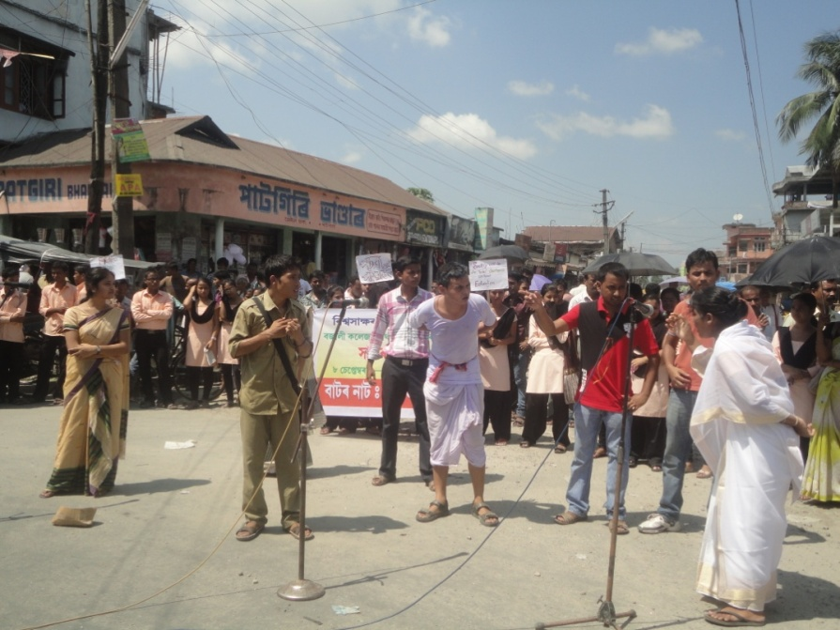

- Cultural Rally
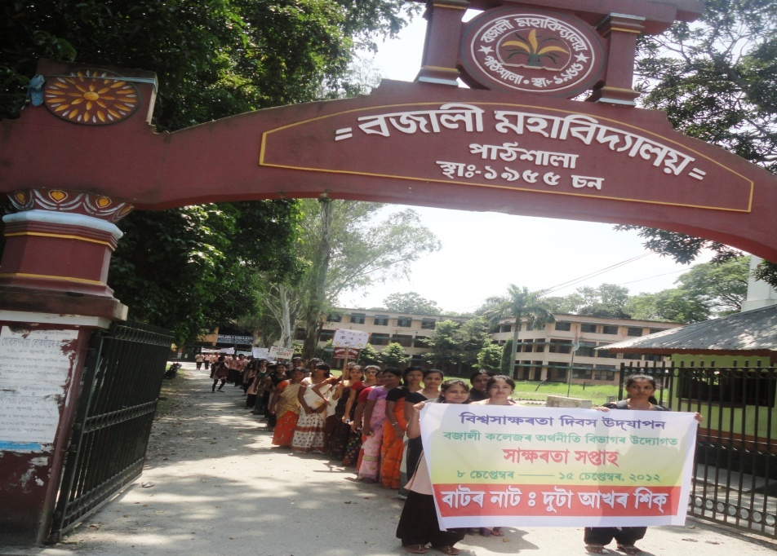

- Seminar/ Workshop/ Talks
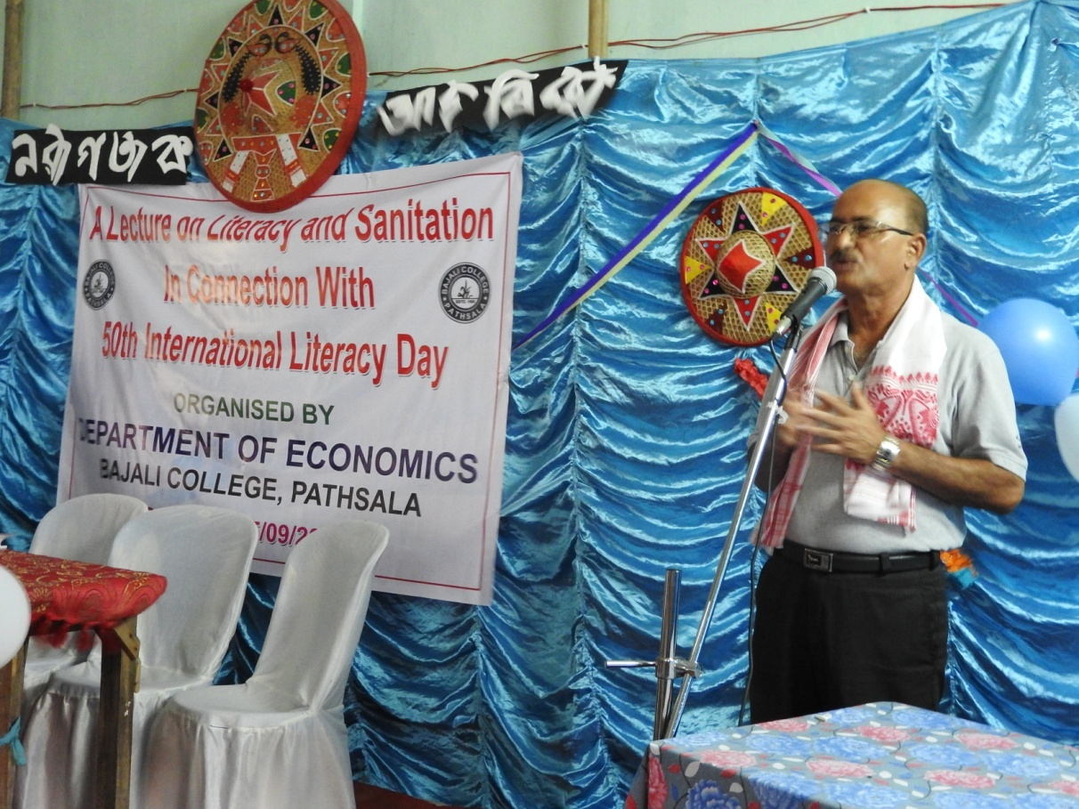
Besides , in the year 2013, our department of organized a UGC sponsored national seminar on “THE CONTEXT OF LIFELONG LEARNING IN HIGHER EDUCATION” in connection with the observation of the International Literacy Day on September 5 & 6. Lifelong Learning is a part of adult literacy.
- Quiz Competition.
- Poster Making Competition.
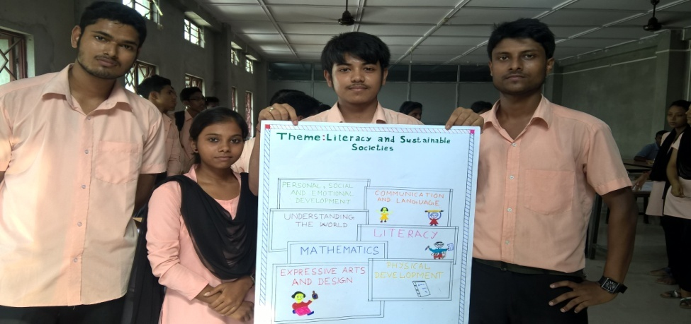
- Extempore Speech Competition
- Group Discussion.
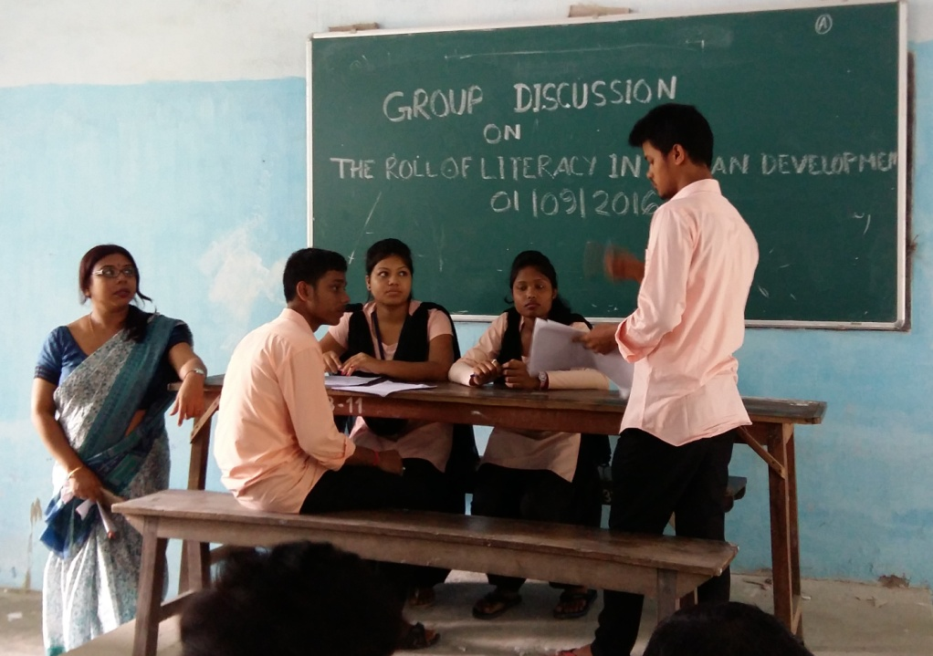

- Essay Writing
- Teaching Assistance Camp
- Exhibition.
Evidence of Success

It has become an important activity in the annual calendar of our college. More and more students from the department as well as other departments look forward to participate in these activities. The regular Celebration of these programmes has made positive impacts as our students and staffs have become the flag bearers of change for a literate society.

Problems Encountered:
Fund is a real problem in organizing this type of activity. The fund is generated from the contribution of Faculties and students which are not sufficient to cover the expenses of the event which is just growing with each passing year.

………………

